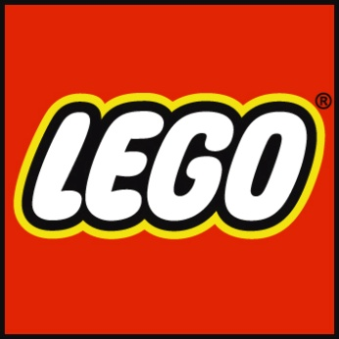****

**Project Support Program**

**Post Project Report**

LCE | LEGO Community Engagement

**PURPOSE**

To stimulate authentic brand advocacy at recognized LEGO® user group driven events in order to inspire and develop the builders of tomorrow.

**POST-PROJECT REPORT**

The information below should be completed and returned to the LEGO Community Team no later than 30 days after the supported project has ended. The information provided in this report is solely for internal use by The LEGO Group and will not be shared with third parties.

1. NUMBER OF PUBLIC VISITORS:

Click here to enter text.

1. PLEASE SHARE ANY LEARNINGS OR REFLECTIONS FROM THE EXECUTION OF THIS PROJECT:

Click here to enter text.

PLEASE PROVIDE US WITH ANY PICTURES, VIDEOS AND/OR ADDITIONAL INFORMATION TO HIGHLIGHT THE SUCCESS OF THIS PROJECT.