# Description

The model is 10.6 feet wide, 3.1 feet deep, and 6 feet tall. There are ~200,000 bricks bonded together around a steel frame for a combined weight of approx. 1800 pounds.

There are “caps” that are not permanently attached, but there is no intended purpose to remove them. They are not affixed to allow for easier repair, if needed. The red lines below indicate roughly where the seams are

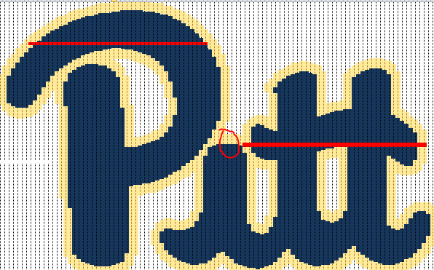

Additionally, there is a small “cap” at the top of the i, between the P and the tt, that can be lifted, slid out, and removed to access the bolts that attach the P to the tt sections.

# Moving

If you’re going to move the sculpture alone, I recommend at least 6 strong lifters.

## Tools needed:

* 8-10 heavy load straps
* 9/16 wrench to remove the bolts for the P
* Rubber coated gloves
* Ratcheting straps and clamps
* Wide/thick wood to use as buffer between clamps or straps and the bricks

## Preparation

Strap or clamp the “caps” of the tt and the P to the bases so they do not become dislodged. Refer to the red lines in the below image for suggested strapping or clamping locations.

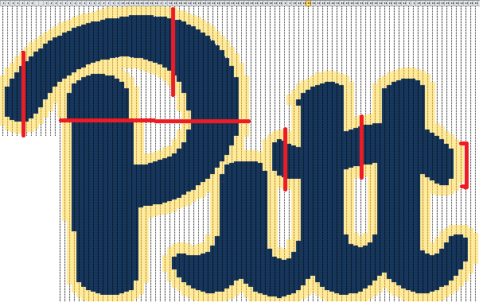

**NEVER** place straps or clamps directly on the bricks. This can lead to damaged bricks. Use wooden spacers, especially at the edges of the bricks.

**NEVER** lift from any of the bricks. Using any point of the bricks as a hold to lift the sculpture could result in splitting or cracking. Only lift from the frame and bottom plates.

It is recommended the entire sculpture be moved as 1 unified piece to maintain joined sections. Having it separate will result in having to spend a lot of time adjusting the sections to get them to fit back together.

# Long term care

**AVOID SUNLIGHT** - The bricks with fade or even darken with prolonged exposure to direct sunlight. There are UV sprays or paints to protect from the sunlight, but some will leave a texture on the bricks that may be undesirable. It is our recommendation to not expose it to sunlight at all, regardless of on UV coating you may chose to apply.

Holes don’t line up in the p

Don’t leave it in direct sunlight

Use shims to level the plates and eliminate gaps