|  |  |
| --- | --- |
| **Name of Event** | 2022 Pittsburgh Home and Garden Show |
| **Dates and times / Doodle URL** | <https://doodle.com/poll/hpga3c2r8kfdie95?utm_source=poll&utm_medium=link> |
| **Address** | David Lawrence Convention center - 1000 Fort Duquesne Blvd, Pittsburgh, PA 15222 |
| **LUG Lead** | Josh Hall – 412 519 4762 |
| **Forum thread** | <http://www.steelcitylug.com/forum/topic/email-pgh-home-and-garden-show-mar-4-13/> |
|  |  |

# Event Summary:

Timing:

Set up: 7am-4p Tuesday March 1st through Thursday March 3rd. Josh will drop off the tables at 7am on Tuesday.

Display: Weekdays 4p-10p, Fri/Sat/Sun 10a-10pm. Friday, March 4th arrive at 8am for a 9am interview for Pittsburgh Today LIVE.

Tear down: Sunday, March 13th 6p-10p (LUG can pick which hourly wave we want to be. Josh will need help taking anything back that can fit, expecting to have stuff returned at the Q1 meeting.

## Exhibit:

Prep: Josh will take up 17 40”x40” custom lug tables with sneezeguard, table skirts, and table cloths. We’ll get electricity to the table. Stanchion to block off access to inner area. We’ll be up against a riverview window to our backs. Display space is 30x20, with a blue brick file being attached to the forum thread.

Content: Anything goes / Fill the tables. Much like the 2021 Brickfest Live event, we’ll have plenty of space and –want- to display a variety of things to engage such a wide audience base.

Downtime: separate blue/white bricks from 2022 First night build. Actively build something from your own list or the unsorted bin.

Other logistics:

Parking at Heinz Field and taking the shuttle is a cheaper option than the $8 convention center parking. The LUG is getting paid for the event, so save receipts to get reimbursed for parking. Street parking is likely cheaper as well.

LUG members will need to check in at the front desk to get exhibitor access each day.

Driving onto the floor of the main wall will be an option, but will need to carry items across the ~50’ carpeted area to our space.

Loading dock:

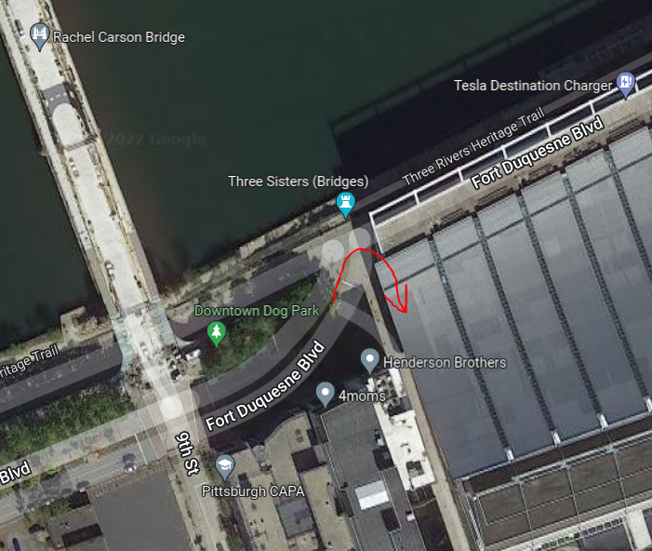

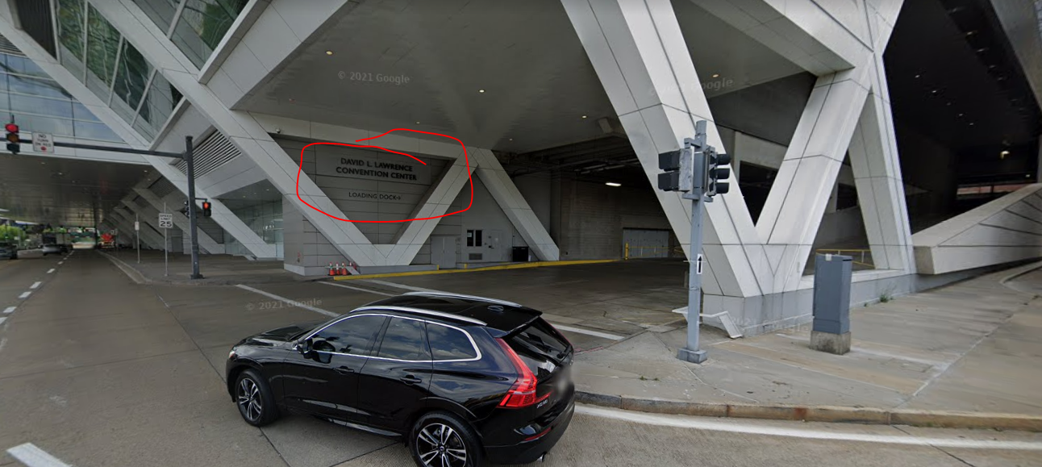

Name cards provided by Krista - <https://forms.gle/KD6Jfx1dGkBbBKwt7>

Steel City LUG Event Checklist - <https://docs.google.com/document/d/19YUYyNyXYD3XUFTQBbt7dfaDVRiPakIBLo-KiPRJ5Gc/edit#heading=h.gjdgxs>

